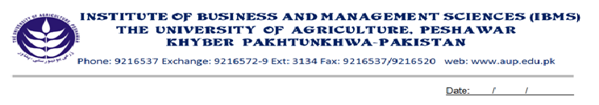Programme: BS (IT)-IV
Course Name: Operating Systems
Course Code: IT-411
Course Hours: 03
Total Weeks: 16
Total Hours: 48

Course Objectives

This course intends to cover the preliminaries of a typical Operating System. Students are exposed to the basic concepts of some market-oriented operating systems. After the completion of this course the students will feel familiar with the logic behind working of a typical operating system. They will have understanding of the topics like resource management, Interrupts, memory management and system security. The topics of these themes will help the students to have orientation to some of the market-oriented operating system.

Week-1
- Software Categories
- Operating System Foundation Concepts

Week-2
- Types of Operating System
- Single User Operating System
- Multi User Operating System

Week-3
- Components of Operating System
- Services/Features of Operating System

Week-4
- Modes of Processing

Week-5
- System Performance
- Nature of Jobs

Week-6
- Buffering
- Spooling
- Caching

Week-7
- Process
- Process States
- Process control block (PCB)
- Possible Operations on Process.
- 3- State Transition Diagram
- 5- State Transition Diagram.
Week-8
- Cooperating Processes
- Inter-Process Communication
- Process Synchronization

Week-9
- CPU Scheduling
- Non-Preemptive Scheduling
- Preemptive Scheduling
- Levels of Scheduling
- Scheduling Algorithms
- First Come First Served
- Shortest Job First
- Priority of Scheduling
- Round Robin Scheduling
- Multi-level Scheduling
- Multi-level Feedback Scheduling

Week-10
- Dead Lock
- Conditions of Dead Lock
- Methods of Dead Lock Removing
- Prevention
- Avoidance
- Detection
- Recovery
Week-11
- Storage Organizations
- Memory Management
- Fixed Partition Memory Management
- Dynamic Partition Memory Management

Week-12
- Memory Management Problems
- Internal Fragmentation
- External Fragmentation
- Memory Management Strategies
- Fetch
- Placement
- Replacement
- Swapping
- Shuffling

Week-13
- Paging (Basic Concepts)
- Paging Address Translation By Direct Mapping
- Paging Address Translation By Associative Mapping
- Paging Address Translation with Combined Direct/Associative Mapping
Week-14
- Segmentation (Basic Concepts)
- Segmentation Address Translation By Direct Mapping
Week-15
- Dynamic Address Translation in Paging/Segmentation System
- Interrupts
- Interrupt Class
Week-16
- File System (Foundation Concepts)
- Comparison of Some Operating Systems

Total Marks: 100

Recommended Books:
- OPERATING SYSTEMS CONCEPTS, Peterson Silberschatz 6th edition (text book)
- OPERATING SYSTEMS, Dietel
- OPERATING SYSTEMS, Tenin bomb

